CGI Assessment Test

Assignment description

   Develop an app where user can

1.submit student name, birth date and address.

2.retrieve all the students information .

                             Backend :- Spring boot, java etc

                              Database:- your choice

                              Front end :- your choice

              Time frame:- ASAP Max time is 1 week

Assignment Submission Details

Submitted By :- Pratik Mehta

Submitted On :- 30th June 2019

Technologies used :-

Backend :- Spring boot (2.1.5) , Java (1.8)

Database :- Mysql (5.7)

FrontEnd :- Jsp, Html, CSS, Bootstraap 4, Javascript, Jquery

Build Tool :- Maven 3

Project Details :-

Download the StudentApp project and navigate into the folder.

Run the below commands to compile and build maven commands (Please make sure you have maven installed on your system)

mvn clean install

mvn spring-boot:run

If the above commands run successfully you will below logs in our console after the application is fully up.

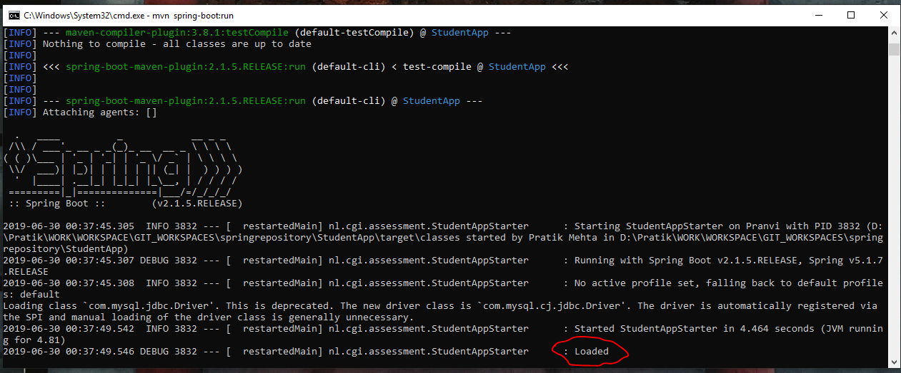

Once you see the above logs you can go to below url to check the application page :-

<http://localhost:9090/cgi/home/>

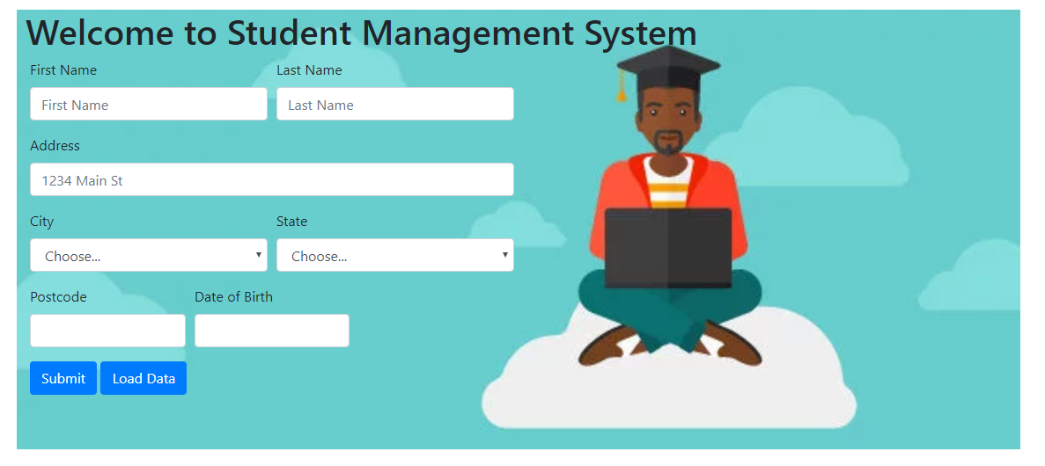

All the fields are mandatory and provide error if not filled.

Once the data is submitted properly you will receive a confirmation .

In order to check the list of students available hit the Load Data button.

If there is no data , a notification will appear with no data found or else table containing all the data

Will be displayed.

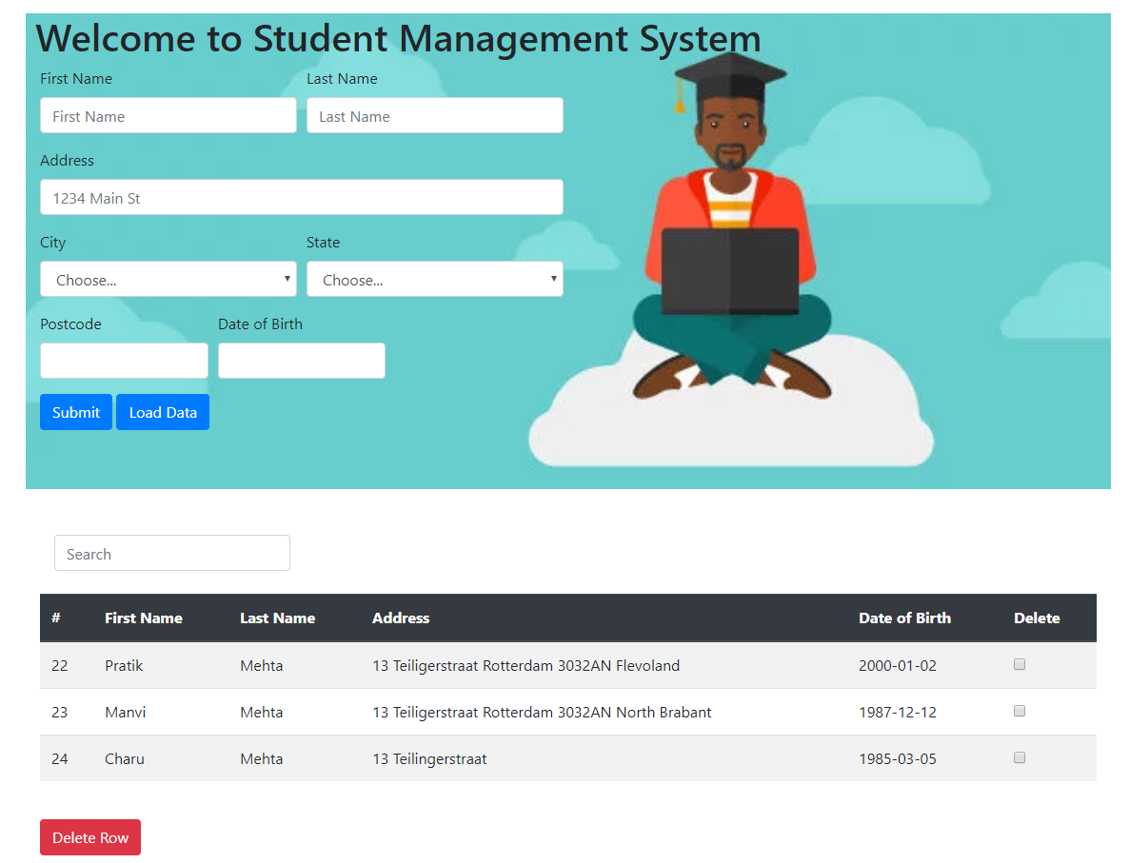

Using the search button you can filter data from the table.

Using the checkbox you can delete any number of rows from table.

All the CRUD rest API calls can be done via POSTMAN as well. Following are the links available for different operations :-

Get List of all students :-

Request type :- GET

Request URL :- <http://localhost:9090/cgi/student>

Response Data :- JSON

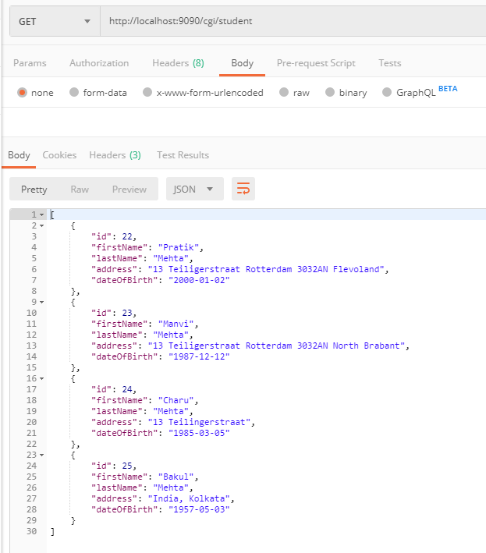

Insert student into the table :-

Request type :- POST

Request URL :- <http://localhost:9090/cgi/student>

Request Data :- JSON

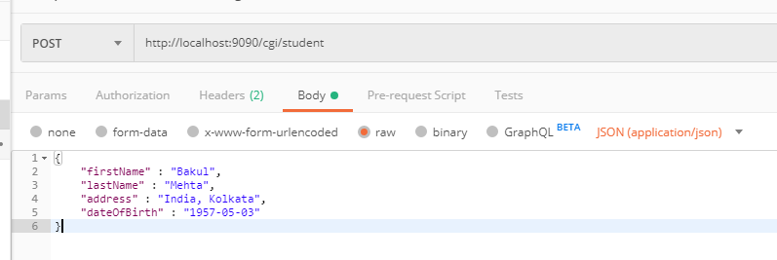

Response Data :- JSON



Get student by ID :-

Request type :- GET

Request URL :- <http://localhost:9090/cgi/student>/{id}

Response Data :- JSON

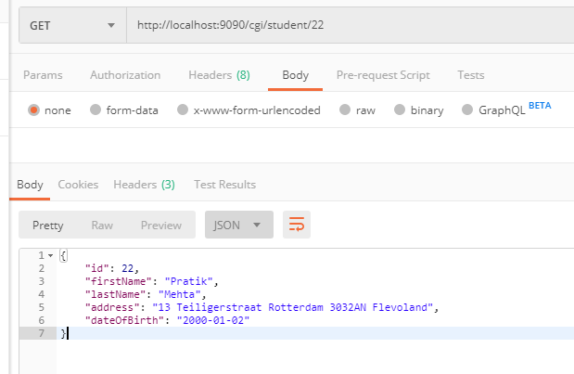

Update Student :-

Request type :- POST

Request URL :- <http://localhost:9090/cgi/student>

Request Data :- JSON

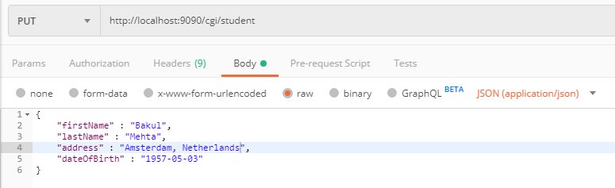

Response Data :- JSON

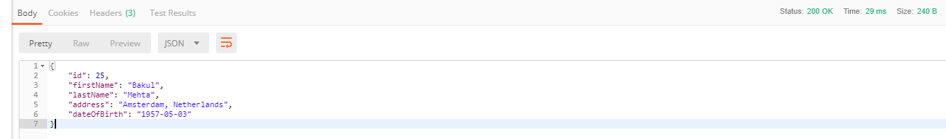

Delete Student By Id :-

Request type :- DELETE

Request URL :- <http://localhost:9090/cgi/student>/{id}

Response Data :- JSON

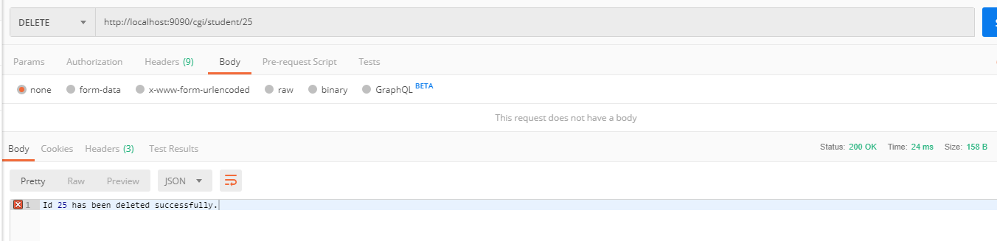

Please let me know if you face any difficulties running any of the queries. Will be more than happy to explain or investigate the issue.